**Acquisition While Loop from 333D01.VI –**

1. Reads 333D01 information (see 333D01 Info.vi)
2. Acquires data from a 333D01 (see the Acquisition Loop)

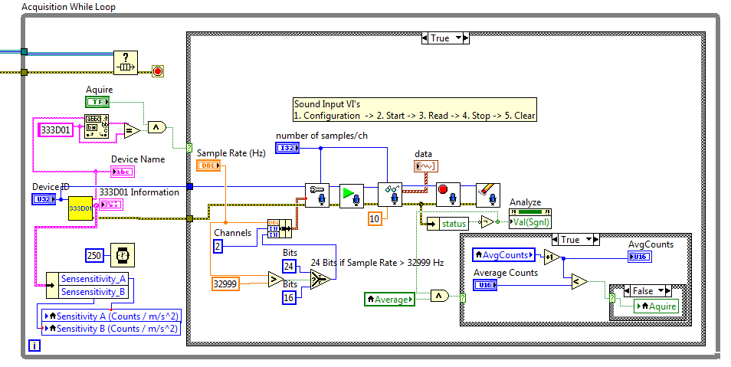

**333D01 Info.vi**

This VI reads the device information from a 333D01 sensor and decodes it to the 333D01 cluster that has the following items:

* Model Number
* Serial Number
* Calibration Date
* Sensitivity_A
* Sensitivity_B

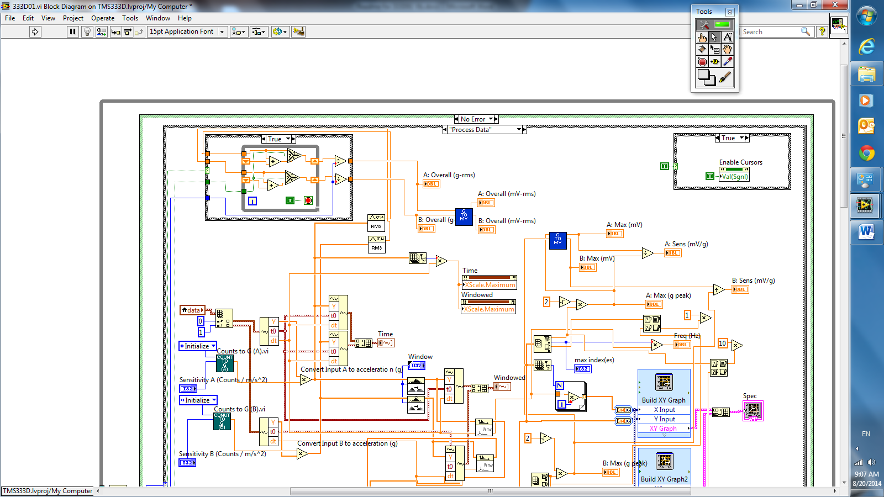

**Converting Sound Input to Acceleration**

Refer to the case, “Process Data,” in the right picture.

Convert the sound input to acceleration in g

Counts to G (A).vi & Counts to G (B).vi  
converts the sensitivity (counts / m/s^2) to g.